Advanced Graphics Techniques Using Vertex and Pixel Shaders

Kenneth L. Hurley

Introduction

Vertex and pixel shaders were introduced with the Geforce 3™ line of products. Stunning visual effects can be achieved by using both Vertex and pixel shaders in combination. Evolving technology is blazing the path for game writers to approach the visual quality of movies. Mass market graphics cards may not have the horsepower to match the quality of Hollywood visual effects, but the rate of change in graphics hardware suggests hardware will catch up to Hollywood in the next 5 years. This chapter will introduce some techniques that can be used in games, helping the programmer direct his efforts towards visually stunning games using the latest techniques.

The techniques presented in this chapter should jump start the programmer, in implementing special effects for their game. Several sections will introduce the reader to special techniques that can be used to accomplish effects that are used in movies. Although these techniques are not up to the standard of Hollywood films, they are a good introduction to techniques that will get the programmer started on the path. The techniques introduced in this chapter will include a particle system using vertex shaders, a velvet effect using vertex and pixel shaders, and brushed metal effect using both vertex and pixel shaders.

The reader is assumed to have a basic understanding of vertex and pixel shaders. Consult the DirectX 8 documentation for information of vertex and pixel shaders. In addition, the reader is assumed to have an understanding of normal maps and the mathematics that is behind them. NVIDIA’S developers website contains valuable information about normal maps and how they work.

Software

Several pieces of important software was used is included on the CD. First and foremost is NVASM. The author, while working for NVIDIA, developed this tool so that developers had a tool that closely resembled tools in the age when everyone was using assembly language. It supports macros, listing files and assembles both vertex and pixel shaders. It is very user friendly and integrates easily into Visual Studio.

Secondly, NVIDIA developed a great framework for developing effects quickly. The “NVEffectsBrowser” is the framework that allows you to develop effects without having to worrying about setting up the Windows components for setting up DirectX. All of this work has been done inside of the Effects Browser. Implementing an effect inside the browser merely consists of adding some code to set up some of the textures and other data such as 3D models.

Advanced Particle Systems with Image Compositing

Particles systems are traditionally done using the CPU, but this technique will demonstrate the power of vertex shaders. Although all of the code in the vertex shader could have been written on the CPU, there are several reasons for doing the particle system in vertex shaders. The first reason is that once the particle system starts, there is no need to update the vertices positions on the CPU side. Using dynamic vertex buffers has a performance penalty; hence static vertex buffers are used for this system. Secondly, the practice of placing more work on the GPU allows more CPU headroom for other tasks. It is still possible to do character physics on the CPU and it is now possible to do better and more accurate physics.

This technique was borrowed with permission from the makers of Illusion. Illusion is a 2D version of what can be accomplished with this code. Illusion is a more robust and better-written program that can do much more than this simple particle system. It also can be very helpful in setting up many of the parameters that go into make the system work. See the website http://www.coolfun.com for more information on their product.

The particle system uses key points that describe how parameters should progress (see Figure 8). There are five key points for a parameter. These reduce to four interpolated parameters, which fit nicely inside four vectors in the vertex shader constant memory.

Setup

Before continuing on to the vertex shader for the particle system, the setup for the system needs to be discussed. Included in the particle system code is a parser that reads a text file similar to that in listing 5. The text file format is very similar to a C/C++ structure in a source code file.

Line 1 of the text file is the name of the particle that contains all the other sub-particles. In this case, “Explosion” is the name of the particle group. Every sub-particle in the group uses the next section as the base parameters when being created. Line 5 is the number of sub-particles that are present in the group. In this example there are five, center, sparkles, outside rim, debris and pang. Each one of these “sub-particles” has a unique texture map.

Line 6 tells the parser and the system, the maximum number of particles to allocate when the particle system is started. Line 7 is used inside the code to do some calculations for key points. Line 8 in the file specifies the length in seconds for the life of the entire particle emitter. Line 9 specifies at what frame number the particles per second change. These are the frame number key points for line 11. Line 11 specifies the number of particles per second that are emitted. Line 12 is the base position where all the particles are emitted. Line 13 is the initial direction of the particles. Lines 14-17 are used as a base value for each of the sub-particles. These values scale the sub-particles controls. These are like a coarse control of the entire particle emitter. Each sub-particle then has the same parameters that allow for a finer level of control. Velocity controls the speed that the particles move in a direction. Weight controls how much the particle falls due to gravity. A negative weight means the particle will rise. Spin means how much the particle will rotate as it is moved and finally the visibility parameter allows the system to specify if the particle is visible or not.

Lines 23-33 are each sub-particles fine control of parameters. The parameters in this section are mostly duplicates of the parameters in the base section. A couple of parameters were added that specify the texture map to use, the life of this sub-particle and its size.

Lines 35-46 are used when a single sub-particle is emitted. It specifies parameters that allow random variations in parameters for each of the sub-particles that are emitted.

- Explosion
- {
- PARAMETERS
- {
- 5, // number of subparticles
- 500.0f, // maximum particles to allocate for
- 30.0f, // frame rate
- 6.666f, // number of seconds (life)
- 0.0f, 7.0f, 10.0f, 10.0f, 10.0f, // key points for particle quantities
- // per second in # frames
- 130.0f, 130.0f, 0.0f, 0.0f, 0.0f, // particles released per second
- 0.0f, 0.0f, -1.0f, // position
- 0.0f, 0.0f, 0.0f, // direction
- 20.0f, // velocity scale
- .3f, // weight scale
- 1.0f, // Spin amount scale
- 1.0f // visibility

- Center
- {
- PARAMETERS
- {
- "center.dds", // name of texture map
- 1.33f, // life in seconds
- 1.0f, // number of particles scale
- 256.0f, 256.0f, 0.0f, // size of initial particle X,Y,Z
- 0.0f, 0.0f, 0.0f, // direction
- 1.0f, // velocity
- -.10f, // weight
- .07f, // spin
- 1.0f // visibility
- 0.0f // alignment flag
- }

- VARIATIONS
- {
- 0.0f // life
- 0.0f, // number of particles
- 0.0f, 0.0f, 0.0f, // position offset
- 1.0f, 1.0f, 1.0f, // direction
- 0.0f, // velocity
- 0.0f, // weight
- .20f, // spin
- 1.0f // visibility
- 1.0f // alignment flag
- }

- LIFEPARAMETERS
- {
- 0.08f, 1.0f, 2.0f, 2.0f, // Direction time percentages of life
- //, 2.0 = out of range
- 1.0f, 2.0f, 2.0f, 2.0f, // Spin time percentages
- 0.10f, 1.0f, 2.0f, 2.0f, // Velocity time percentages
- 1.0f, 2.0f, 2.0f, 2.0f, // Weight time percentages
- 0.09f, 0.20f, 0.53f, 1.0f, // Color/transparency percentages

- 0.0f, 0.0f, 0.0f, 1.0f, // direction key 1
- 0.0f, 0.0f, 0.0f, 1.0f, // direction key 2
- 0.0f, 0.0f, 0.0f, 1.0f, // direction key 3
- 0.0f, 0.0f, 0.0f, 1.0f, // direction key 4
- 0.0f, 0.0f, 0.0f, 1.0f, // direction key 5

- 1.0f, 0.0f, 2.0f, 1.0f, // Spin/NULL/Velocity/Weight key 1
- -1.0f, 0.0f, 0.0f, 1.0f, // Spin/NULL/Velocity/Weight key 2
- -1.0f, 0.0f, 0.0f, 1.0f, // Spin/NULL/Velocity/Weight key 3
- -1.0f, 0.0f, 0.0f, 1.0f, // Spin/NULL/Velocity/Weight key 4
- -1.0f, 0.0f, 0.0f, 1.0f, // Spin/NULL/Velocity/Weight key 5

- 0x56565656, // RGBA, key 1
- 0xfff695ff, // RGBA, key 2
- 0xe98011e9, // RGBA, key 3
- 0x00000000, // RGBA, key 4
- 0x00000000 // RGBA, key 5
- }
- }

- Sparkles
- {

- }

- OutsideRim
- {
- }

- Debris
- {
- }

- Pang
- {
- }
- }
- }

Explanation of Vertex Shader

The vertex shader in Listing 1 is the code that controls the particle system.

Vertex Shader (Listing 1)

- ; This code does the particle updates based on time
- ; that is passed in through a constant
- ;

- #include "constants.h"

- #define PARTICLE_POSITION v0.xyz
- #define PARTICLE_VELOCITY v0.w
- #define PARTICLE_DIRECTION v1.xyz
- #define PARTICLE_WEIGHT v1.w
- #define PARTICLE_SPIN v2.x
- #define PARTICLE_XYOFFSET v2.yz
- #define PARTICLE_START_TIME v2.w
- #define PARTICLE_INIT_ALIGN v3.x
- #define PARTICLE_DUMMY v3.y
- #define PARTICLE_TEXTURE_COORD v3.zw

- #define DEST_TEX_COORD oT0
- #define DEST_COLOR_DIFFUSE oD0

- #define DEST_INTERP_DIRECTION r2
- #define DEST_INTERP_SPIN r3.xy
- #define DEST_INTERP_SPINX r3.x
- #define DEST_INTERP_SPINY r3.y
- #define DEST_INTERP_VELOCITY r3.w
- #define DEST_INTERP_WEIGHT r3.z
- #define DEST_INTERP_COLOR r4

- #define PERIODOCITY r7.x
- #define PERIODOCITY_SQR r7.y

- vs.1.1

- add r0, c[CV_PERIODOCITY].x, PARTICLE_START_TIME
- // see if time is > particle start time
- sge r11, r0, CV_ZERO
- mul r7, r11, r0
- // square periodocity
- mul r7.y, r7.x, r7.x

- // set 1's where PERIODOCITY > timestamps
- sge r0, PERIODOCITY, c[CV_PARVAR_DIRECTION_TIME]
- sge r1, PERIODOCITY, c[CV_PARVAR_SPIN_TIME]
- sge r2, PERIODOCITY, c[CV_PARVAR_VELOCITY_TIME]
- sge r3, PERIODOCITY, c[CV_PARVAR_WEIGHT_TIME]
- sge r4, PERIODOCITY, c[CV_PARVAR_COLOR_TRANSP_TIME]

- // create indices to look up into tables
- dp3 r5.x, r0, CV_ONE
- dp3 r5.y, r1, CV_ONE
- dp3 r5.z, r2, CV_ONE
- dp3 r5.w, r3, CV_ONE
- dp3 r6.x, r4, CV_ONE

- // lookup direction interpolant
- mov a0.x, r5.x
- sub r1, PERIODOCITY, CV_PARVAR_DIRECTION_START_TIME
- mov r0, CV_PARVAR_DIRECTION_1
- mul r8, r1, CV_PARVAR_DIRECTION_DELTA_TIME
- sub r9, r0, CV_PARVAR_DIRECTION_0
- mad DEST_INTERP_DIRECTION, r8, r9, CV_PARVAR_DIRECTION_0

- // calculate spin tn = periodocity, a = acceleration, v0 = initial spin
- // c = vertex multiplier
- // spin = c * ((v0 * tn) + (1/2 * a * tn^2) + lastSpin end solution)
- mov a0.x, r5.y
- mul r8, PERIODOCITY_SQR, CV_PARVAR_SPIN_ACCELERATION
- mov r9, CV_PARVAR_PREV_SPIN
- mad r0, PERIODOCITY, CV_PARVAR_SPIN, r9
- mad r1, r8, CV_HALF, r0

- mul r1, r1, PARTICLE_SPIN
- // scale to by PI and add in intial alignment rotation
- mad r1, r1, CV_PI, PARTICLE_INIT_ALIGN

- // convert spin to 2d vector, x = cos(angle) * x + sin(angle) * y, y = -sin(angle) * x + cos(angle) * y

- // bring argument into -pi .. +pi range
- mad r0.x, r1.x, CV_ONE_OVER_2PI, CV_PI_TABLE_HALF
- expp r0.y, r0.x
- mad r0.x, r0.y, CV_2PI, -CV_PI
- // generate 1, (r0.x)^2 .. (r0.x)^6 taylor series, r2.xyzw
- dst r8.xy, r0.x, r0.x
- mul r8.z, r8.y, r8.y
- mul r8.w, r8.y, r8.z

- // generate r0.x, (r0.x)^3 .. (r0.x)^7 taylor series
- mul r0, r8, r0.x

- // compute sin(r0.x)
- dp4 r0.y, r0, CV_PI_TABLE2
- // now compute cos(r0.x)
- dp4 r0.x, r8, CV_PI_TABLE1

- // make -sin
- mov r0.z, -r0.y
- // zero out w component
- slt r0.w, r0, r0

- dp3 DEST_INTERP_SPINX, r0.xyww, PARTICLE_XYOFFSET
- dp3 DEST_INTERP_SPINY, r0.zxww, PARTICLE_XYOFFSET

- // calculate velocity tn = periodocity, a = acceleration, v0 = initial velocity
- // c = vertex multiplier
- // velocity = c * ((v0 * tn) + (1/2 * a * tn^2) + lastVelocity end solution)
- mov a0.x, r5.z
- mul r8, PERIODOCITY_SQR, CV_PARVAR_ACCELERATION
- mov r9, CV_PARVAR_PREV_VELOCITY
- mad r0, PERIODOCITY, CV_PARVAR_VELOCITY, r9
- mad DEST_INTERP_VELOCITY, r8, CV_HALF, r0

- // calculate weight tn = periodocity, g = gravity, v0 = initial weight (velocity)
- // c = vertex multiplier
- // weightvelocity = c * ((v0 * tn) + (1/2 * g * tn^2) + lastWeight end solution)
- mov a0.x, r5.w
- mul r8, PERIODOCITY_SQR, CV_PARVAR_GRAVITY
- mov r9, CV_PARVAR_PREV_WEIGHT
- mad r0, PERIODOCITY, CV_PARVAR_WEIGHT, r9
- mad DEST_INTERP_WEIGHT, r8, CV_HALF, r0

- // finally, lookup color interpolant
- mov a0.x, r6.x
- sub r1, PERIODOCITY, CV_PARVAR_COLOR_START_TIME
- mov r0, CV_PARVAR_COLOR_TRANSP_1
- mul r8, r1, CV_PARVAR_COLOR_DELTA_TIME
- sub r9, r0, CV_PARVAR_COLOR_TRANSP_0
- mad DEST_INTERP_COLOR, r8, r9, CV_PARVAR_COLOR_TRANSP_0

- // add time step direction to initial direction
- add r5, DEST_INTERP_DIRECTION, PARTICLE_DIRECTION

- // multiply velocity * accleration (velocity scale)
- mul r10, PARTICLE_VELOCITY, DEST_INTERP_VELOCITY
- // no multiply velocity * direction
- mul r0, r10, r5

- // calculate weight * gravity
- mul r9, DEST_INTERP_WEIGHT, PARTICLE_WEIGHT
- // make direction vector in y only, first zero out everything
- mov r6, CV_ZERO
- // now multiply y direction * gravity/weight calculation, but only affect r6.y
- mul r6.y, -CV_ONE, r9

- // add (velocity * direction) + (gravity(weight) * y-direction)
- add r8, r0, r6

- // now add in position
- add r1, r8, PARTICLE_POSITION

- // don't update position yet, if not time not > 0.0f
- mul r1, r1, r11
- mov r1.w, CV_ONE

- ;transform position
- dp4 r0.x, r1, c[CV_WORLDVIEWPROJ_0]
- dp4 r0.y, r1, c[CV_WORLDVIEWPROJ_1]
- dp4 r0.z, r1, c[CV_WORLDVIEWPROJ_2]
- dp4 r0.w, r1, c[CV_WORLDVIEWPROJ_3]

- add r0.xy, r0.xy, DEST_INTERP_SPIN
- mov oPos, r0

- ; Output texture coordinates
- ; alpha contains fadeout value/ color
- mul DEST_COLOR_DIFFUSE, r11, DEST_INTERP_COLOR

- mov DEST_TEX_COORD.xy, PARTICLE_TEXTURE_COORD
- mov DEST_TEX_COORD.zw, CV_ONE

Blending

The particle system demo uses the fixed function pipeline for the rendering of pixels. It does not use a pixel shader. To this end, the setup for the texture stages states was simply set to modulate the texture by the diffuse color and then alpha blend the values into the frame buffer. The result can be seen in Figure 1.

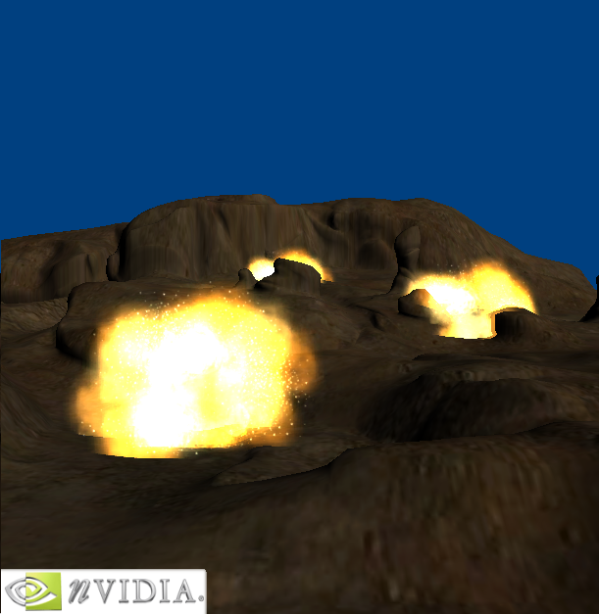
Figure 1

Minneart Lighting, Velvet

Using a technique known as Minnaert Lighting the look of velvet can be simulated. Minneart^{[3]} studied the lighting conditions of the moon in 1946 and came up with calculations that allow for the reconstruction of lighting conditions for certain materials. Even though better techniques have been developed, Minneart lighting can simulate the look of velvet. The technique adds what are called “darkening limbs” to a material. This can be seen from figure 2.

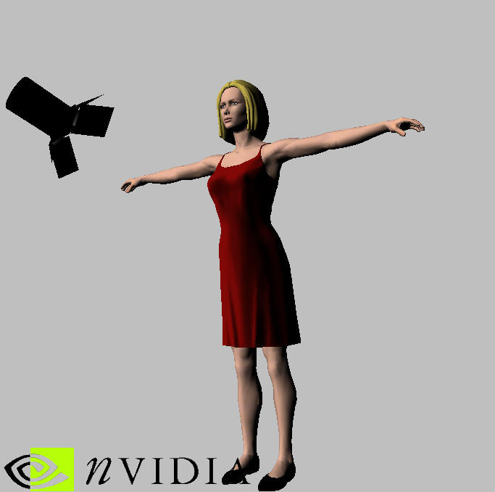
Figure 2

Vertex Shader (Listing 2)

- ; v0 -- position
- ; v1 -- normal
- ; v2 -- tex coord
- ;
- ; c0-3 -- world/view/proj matrix
- ; c4 -- light vector
- ; c5 -- eye point
- ; c6 -- 1.0f

- #include "constants.h"

- #define srcPosition v0
- #define srcNormal v1
- #define srcTexCoord v2

- #define destNormTex oT0
- #define destLightTex oT1
- #define destEyeTex oT2
- #define destNormTex2 oT3

- vs.1.0

- ;transform position
- dp4 oPos.x, srcPosition, c[CV_WORLDVIEWPROJ_0]
- dp4 oPos.y, srcPosition, c[CV_WORLDVIEWPROJ_1]
- dp4 oPos.z, srcPosition, c[CV_WORLDVIEWPROJ_2]
- dp4 oPos.w, srcPosition, c[CV_WORLDVIEWPROJ_3]

- ; get light direction from vertex
- ; because this is a directional light.

- mov destLightTex, c[CVP_LIGHT_DIRECTION]

- #ifdef MODULATE_COLOR
- ; get vertex position to eye position (-eye vector)
- sub r0, c[CV_EYE_POSITION], srcPosition

- ; normalize the new vector
- dp3 r0.w, r0, r0
- rsq r0.w, r0.w
- mul destEyeTex, r0, r0.w
- ; destEyeTex coordinate now has normalized vector vertex->eye
- mov destEyeTex.w, c[CV_ONE]

- #else
- mov destEyeTex, srcNormal
- #endif
- mov destNormTex, srcNormal
- mov destNormTex2, srcNormal
- mov destNormTex2.w, c[CV_ONE]

- mov oD0, c[CV_MATERIAL_COLOR]

Pixel Shader (Listing 3)

- //
- // Pixel shader - BRDF
- // This is actually minneart reflections
- //
- //

- #include "constants.h"

- // Declare pixel shader version 1.0
- ps.1.0

- tex t0
- texm3x2pad t1,t0_bx2 // dot normal with light vector (S coordinate)
- texm3x2tex t2,t0_bx2 // dot normal with eye vector (T coordinate)
- tex t3 // grab bump map normal

- #ifdef MODULATE_COLOR

- dp3_sat r1, c[CVP_LIGHT_DIRECTION]_bx2, t3_bx2

- mul r0, r1, t2 // multiply in darkening limbs
- mul r0, r0, v0 // multiply by diffuse color
- #else
- mov r0,t2
- #endif

Brushed Metal

The brushed metal technique that will be described in this section can be seen in Figure 4. The tire tread around the tire could have been updated with a bump map and some specular highlights, but the effect is presented to demonstrate how to use high resolution normal maps with texture lookups for diffuse and specular lighting. Normal mapping is a concept that is very difficult to explain. For an explanation of how Normal mapping works, see http://developer.nvidia.com and search for the keywords normal maps.
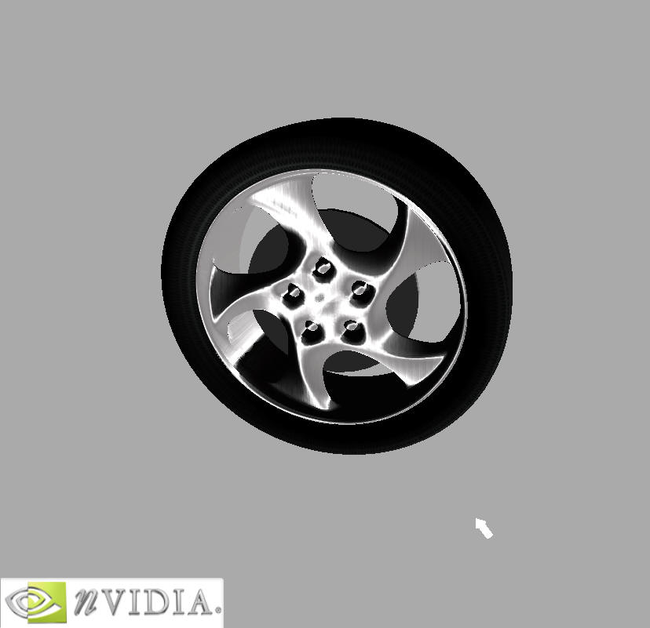
Figure 4

This effect is by far the hardest to implement and understand. It not only uses normal map techniques discussed early, but it uses a pixel shader that doesn’t use textures maps in the traditional sense. In fact the brushed metal isn’t really using any diffuse texture map at all. The technique implemented simply takes the properties of the material and uses texture maps to calculate what would happen on a pixel-by-pixel basis.

N • L lookup in RGB, N • H in alpha

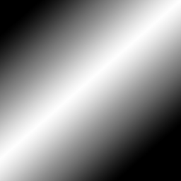
Figure 4 Figure 5

Combine with faked high resolution bump map
What is meant by fake?

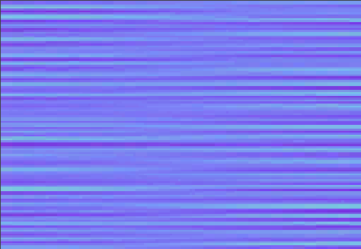
Figure 6

Vertex Shader (Listing 4)

- /******************************************************************************
- Path: C:\development\
- File: dot3_directional.nvv

- Copyright (C) 2002 Kenneth L. Hurley - Free for Any use whatsoever
- This file is provided without support, instruction, or implied warranty of any
- kind. Kenneth L. Hurley makes no guarantee of its fitness for a particular purpose
- and is not liable under any circumstances for any damages or loss whatsoever
- arising from the use or inability to use this file or items derived from it.

- Comments:
- Kenneth Hurley - 10/15/2001

- ******************************************************************************/

- #include "PF_Constants.h"

- #define S_OBJECT r0
- #define T_OBJECT r1
- #define SxT_OBJECT r2
- #define LIGHT_OBJECT r3
- #define VERTEX_WORLD r4
- #define EYE_VECTOR r5

- #define HALF_ANGLE r7

- vs.1.0

- ; Transform position to clip space and output it
- dp4 oPos.x, V_POSITION, c[CV_WORLDVIEWPROJ_0]
- dp4 oPos.y, V_POSITION, c[CV_WORLDVIEWPROJ_1]
- dp4 oPos.z, V_POSITION, c[CV_WORLDVIEWPROJ_2]
- dp4 oPos.w, V_POSITION, c[CV_WORLDVIEWPROJ_3]

- // scale bumps by amount requested
- mul S_OBJECT.xyz, V_S.xyz, c[CV_BUMP_SCALE].w
- mul T_OBJECT.xyz, V_T.xyz, c[CV_BUMP_SCALE].w

- ; transform parallel light direction by basis vectors to put it into texture space
- dp3 LIGHT_OBJECT.x, S_OBJECT, c[CV_LIGHT_DIRECTION]
- dp3 LIGHT_OBJECT.y, T_OBJECT, c[CV_LIGHT_DIRECTION]
- dp3 LIGHT_OBJECT.z, V_SxT, c[CV_LIGHT_DIRECTION]

- ; Normalize the light vector
- dp3 LIGHT_OBJECT.w, LIGHT_OBJECT, LIGHT_OBJECT
- rsq LIGHT_OBJECT.w, LIGHT_OBJECT.w
- mul LIGHT_OBJECT, LIGHT_OBJECT, LIGHT_OBJECT.w

- /////////////////////////////////////
- // Calculate half angle vector

- ; Half angle vector is (L+V)/||L+V|| or Normalize( L+V )
- ; ||a|| is magnitude of a
- ; L = vec to light from vertex point
- ; V = vec to viewer from vertex point

- // vertex position - eye position
- // eye position - vertex position
- add EYE_VECTOR, c[ CV_EYE_POS_OBJECT ], -V_POSITION.xyz

- ; Normalize eye vec
- dp3 EYE_VECTOR.w, EYE_VECTOR, EYE_VECTOR
- rsq EYE_VECTOR.w, EYE_VECTOR.w
- mul EYE_VECTOR, EYE_VECTOR, EYE_VECTOR.w

- // Add them to average & create half angle vector
- add HALF_ANGLE, c[CV_LIGHT_DIRECTION], EYE_VECTOR

- // Normalize it
- dp3 HALF_ANGLE.w, HALF_ANGLE, HALF_ANGLE
- rsq HALF_ANGLE.w, HALF_ANGLE.w
- mul HALF_ANGLE, HALF_ANGLE, HALF_ANGLE.w

- // transform half angle into normal map space
- dp3 oT3.x, HALF_ANGLE, V_S
- dp3 oT3.y, HALF_ANGLE, V_T
- dp3 oT3.z, HALF_ANGLE, V_SxT
- mov oT3.w, c[ CV_ONE ]

- /////////////////////////////////////
- // move light vector to TC 2

- mov oT2.xyz, LIGHT_OBJECT.xyz
- mov oT2.w, c[CV_ONE].w // w to 0

- ; output tex coords
- mov oT0, V_TEXTURE
- mov oT1, V_TEXTURE

Pixel Shader (Listing 5)

- tex t0 // fetch base texture
- tex t1 // fetch normal map
- texm3x2pad t2, t1_bx2 // u = ( t1=N ) dot ( t2=L )
- texm3x2tex t3, t1_bx2 // v = ( t1=N ) dot ( t3=H )
- // fetch texture 4 at (u,v)
- mov r1, t3 // RGBA diffuse,alpha into r1

- mul r0, r1, t0 // Diffuse * base texture

- mul r1, t3.a, t3.a // spec * spec

- mad r0, r1, c1, r0 // (spec * constant) + diffuse

Conclusion

References

[1] Jim Blinn, "Simulation of Wrinkled Surfaces", Computer Graphics, (Proc. Siggraph), Vol. 12, No. 3, August 1978, pp. 286-292
[2] Jim Blinn. Models of Light Reflection For Computer Synthesized Pictures. In Computer Graphics (SIGGRAPH '77 Proceedings), pages 192-198, July 1977
[3] Minnaert, M., 1941. The reciprocity principle in lunar photometry. Astrophysical Journal, Volume 93, pp. 403-410

