Cube Maps for GeForce 256
Dispelling the Myths
Kenneth L. Hurley
Please send me comments/questions/suggestions
khurley@nvidia.com

Introduction

Cube maps are not just for static environment maps. In an attempt to dispel some myths about cube maps, some new techniques have been developed for using cube maps in interesting ways. Most people think that cube maps can only be used for static environment maps. A better way to think about cube maps is to think of them as functions that are based on angles instead of the u,v coordinates typically used in texture addressing.

Misconception #1 - Cube maps used for Environment maps have to be created every frame.

This simply is not true. The only things that need to be redrawn into a cube map are moving objects. The world contains mostly static objects. You can pre-render cube maps with all the static objects then copy those texture maps. You may also want to save the Z/W-Buffer. This technique does not have much overhead, as cube maps can be low resolution. When it comes time to render your scene with cube maps. Just copy the texture maps and/or depth buffers back and then render your dynamic objects. Use BLT so the copy will be placed into the pipeline and avoid stalling it. You can also use lower resolution models when rendering into the cubemap.

Misconception #2 - You only can use cube maps for mapping the environment to objects.

This is a little more complicated, but here goes. Cube maps are lookup tables that can be used in combination with the texture combiners to do other things. You have to let your imagination run wild with this. Here are a few ideas that are being worked on in regards to cube mapping.

- Lighting effects -

BRDF'S - Bidirectional Reflectance Distribution Function - Several papers have been written on this type of lighting. The basic idea is to use separate 2D functions to approximate a 4D function. Another idea is to break out the light component of the equation and use a cube map to look up the other functions. You then can use the D3DTOP_DOTPRODUCT3 texture combiner function to bring the light vector back into play.

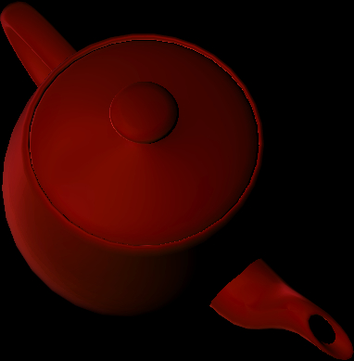

Specular Maps - Using cube maps allow for a greater degree of freedom when rendering specular maps. You can use these in combination with the texture combiners to achieve highlights based on specular lighting.

Phong Shading - Since cube maps can be used to interpolate vectors spherically, you can get phong shading.

Shadow Maps – You really don’t want to use a cubemap for shadowmaps…

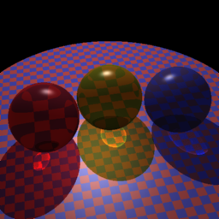

- Refraction -

There are three ways to generate texture coordinates with which to index into a cube map. The most common is camera space reflection. This calculates a proper reflection vector in view space, taking into account the viewpoint, the vertex position and normal. Two other ways to generate texture coordinates are camera space normal and camera space position. By rendering back faced triangles, using the texture matrix capabilities and the camera space normal texture coordinate generation you can approximate refraction through an object. This allows special effects like semi-transparent objects such as water and glass.

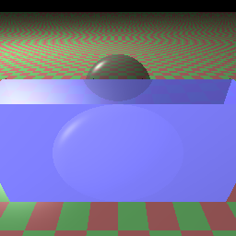

- Bump Mapping -

The GeForce256 can achieve pixel perfect bump mapping with the use of cube maps. There is a torus demo located on developer web site that shows how to do this using OpenGL.

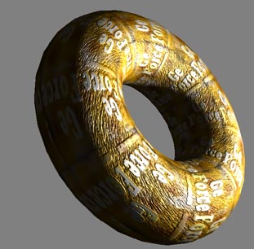

- Renormalization/ Cartoon Rendering -
Treating the cube map as vector look ups you can achieve vector renormalization. In addition, you can use cube maps to help find silhouette edges with respect to a directional light or for an orthographic projection.
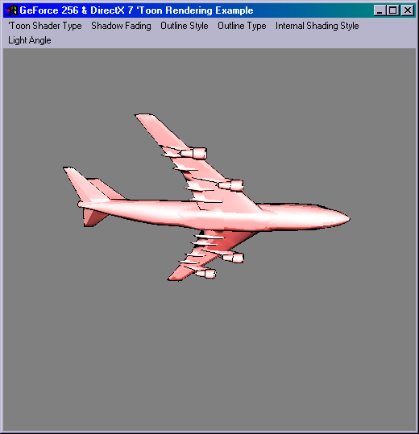

- Other Uses -

You can really use your imagination when it comes to cube maps. If you think of them as vector lookups look-ups, the possibilities are limitless. Uses for the camera space position capabilities are being looks into, so if you have any suggestions, please email them to the address above.

Closing Remarks

Cube maps can be used for a lot of things besides environment maps. The GeForce fully supports cube maps and in fact you can use two of them at a time. This combined with the texture matrix, dot product 3 and combiners provide you with almost limitless possibilities when it comes to rendering.

